Los Angeles Leadership Academy
AGREEMENT FOR CONSULTANT SERVICES

This Agreement entered into this 18th day of May 2021, is made by and between AFTER-SCHOOL ALL-STARS, LOS ANGELES (ASAS, LA) herein called CONSULTANT and the Los Angeles Leadership Academy (LALA), hereinafter called the DISTRICT.

WITNESSETH:

WHEREAS, the Consultant agrees to render the following services herein stated in accordance with directions stipulated by the District Superintendent of Schools or designee:

I. CONSULTANT SERVICES

The District requires the services of After School Consultant. The consultant agrees to provide the following services:

- Coordinate and manage a Middle School After School Program at LALA. Provide staffing, materials and management of after school grant for 111 students per day, 180 days.
- Will follow and abide funding terms and conditions of ASES grant and submit all required reports to CDE with copies to LALA.

II. TERMS OF AGREEMENT

The terms of Agreement services shall be for the period effective July 1, 2021- June 30, 2022.

III. PAYMENT FOR SERVICES

- Amount not to exceed $177,599.20 for services performed in accordance with agreement.
- The Consultant shall submit a monthly invoice reconciling with submitted CDE Expenditure Reports. LALA will pay for services rendered and costs incurred within 14 days of receipt of invoice.

IV. RESPONSIBILITY FOR PROFESSIONAL SERVICES

LALA, not being skilled in the special services contemplated herein, relies upon the professional ability of Consultant as a material inducement to enter into this agreement. Consultant agrees to use all reasonable care and diligence to perform these services under the agreement in a manner acceptable to the Superintendent/President, it being understood that the acceptance of his/her services or advice by the District shall not operate as waiver or release of the Consultant.

V. TERMINATION
LALA may, by written notice to CONTRACTOR, terminate this Contract in whole or in part at any time, for LALA’s convenience. Upon receipt of such notice, CONTRACTOR shall:
- Immediately discontinue all services affected (unless the notices direct otherwise); and
- Deliver to LALA all information and material as may have been involved in the provision of services whether provided by LALA or generated by CONTRACTOR in the performance of this Contract, whether completed or in process. Termination of this Contract shall be as of the date of receipt by CONTRACTOR of such notice

If the termination is for the convenience of LALA, CONTRACTOR shall submit a final invoice within 60 days of termination and LALA shall pay CONTRACTOR the sums earned for the services actually performed prior to the effective date of termination and other costs reasonably incurred by CONTRACTOR to implement the termination in accordance with the provision of this Contract.
This agreement may be terminated at any time for any unspecified reason at the sole discretion of the District. District will only pay for services previously provided as of the date of termination.

VI. SCHOOL/DISTRICT COOPERATION

The School/District will cooperate with Consultant by furnishing all necessary District records and an opportunity to consult with District personnel as necessary to perform required work.

VII. CONFIDENTIALITY OF INFORMATION

It is mutually agreed that the Consultant shall regard all information received during the performance of services pursuant to this agreement as confidential and shall not disclose such information to any other person without prior consent of the District.

VIII. CONSULTANT NOT AN EMPLOYEE OF DISTRICT

Consultant shall have no authority to contract on behalf of the District. It is expressly understood and agreed by both parties hereto that the Consultant, while engaged in carrying out and complying with any terms and conditions if this contract, is an independent contractor and not an officer, agent or employee of aforesaid District.

IX. HOLD HARMLESS AGREEMENT

The Consultant agrees to indemnify and hold harmless the District, its officers, agents and employees from each claim, or demand made, and every liability, loss, damage or expense, or any nature whatsoever, which may be incurred by reason of:

- Liability for damages (1) death or bodily injury to persons; (2) injury to property; (3) design defects; or (4) any loss, damage or expense arising under either 91), (2) or (3) above, by Consultant upon or in connection with the work called for in this agreement except for liability or damages referred to above which result from sole negligence or willful misconduct of District, its officers, employees, agents or independent contractor who are directly employed by District, and;
- Any injury to or death of persons or damage to property, sustained by any person, firm or corporation, including the District, caused by any act, neglect, default, or omission of Consultant or any person, firm, or corporation directly or indirectly by Consultant in connection with the work covered by this agreement, whether said injury or damage occurs either on or off school property.
- The Consultant, at his/her own expense, cost and risk, shall defend any and all actions, suits or other proceedings that may be brought or instituted against District, its officers, agents or employees on any such claim, demand or liability and shall pay or satisfy any judgment that may be rendered against District, its officers, agents or employees in any action, suit or other proceedings as a result herein.

X. INSURANCE

CONTRACTOR shall at his, her or its sole cost and expense, maintain in full force and effect, during the term of this Agreement, the following insurance coverage from a California licensed insurer with an A minus (A-), VII or better rating from A.M. Best, sufficient to cover any claims, damages, liabilities, costs and expenses (including counsel fees arising out of or in connection with CONTRACTOR’S fulfillment of any of its obligations under this Agreement or either party’s use of the Work or any component or part thereof:
- Commercial Form General Liability Insurance, including both bodily injury and property damage, with limits as follows:
    - $1,000,000 per occurrence
    - $100,000 fire damage
    - $5,000 medical expenses
    - $1,000,000 personal and adv. Injury
    - $3,000,000 general aggregate (or if CONTRACTOR provides services solely over the Internet or some other means that does not require face to face contact between CONTRACTOR’S employees, agents, or subcontractors and DISTRICT students, CONTRACTOR shall have at least $1,000,000 per occurrence and general aggregate for all damages arising from each accident or occurrence)
    - $3,000,000 products/completed operations aggregate
B. Business Auto Liability Insurance for owned scheduled, non-owned or hired automobiles with a combined single limit of no less than $1,000,000 per occurrence. If CONTRACTOR provides transportation services to students, CONTRACTOR shall ensure that CONTRACTOR keeps in effect a liability insurance policy providing at least $5,000,000 per occurrence and $5,000,000 in aggregate coverage
C. Worker’s Compensation and Employer’s Liability Insurance in a form and amount covering CONTRACTOR’S full liability under the California Worker’s Compensation Insurance and Safety Act and in accordance with applicable state and federal laws.
Part A - Statutory Limits
Part B - $1,000,000/$1,000,000/$1,000,000 Employer’s Liability
D. Errors and Omissions (Professional Liability) coverage, when applicable, with the following limits: $1,000,000 per occurrence/$1,000,000 aggregate.

XI. ASSIGNMENT AND SUBLETTING
Consultant shall not assign, sublet or transfer his/her interest in this agreement, nor shall this agreement be assignable or transferable by operation of law or otherwise, without the prior written consent of the District.

XII. AGREEMENT MODIFICATIONS

This agreement may not be modified, revised or amended in any fashion without the express written consent of the District.

IN WITNESS WHEREOF, the parties to this agreement have hereunto caused the same to be executed the day and year written below.

Los Angeles Leadership Academy
2670 Griffin Ave.
Los Angeles, CA 90031

BY___________________________________________________________

AFTER-SCHOOL ALL-STARS, LOS ANGELES (ASAS, LA)
6501 Fountain Ave.
Los Angeles, CA 90028

BY: 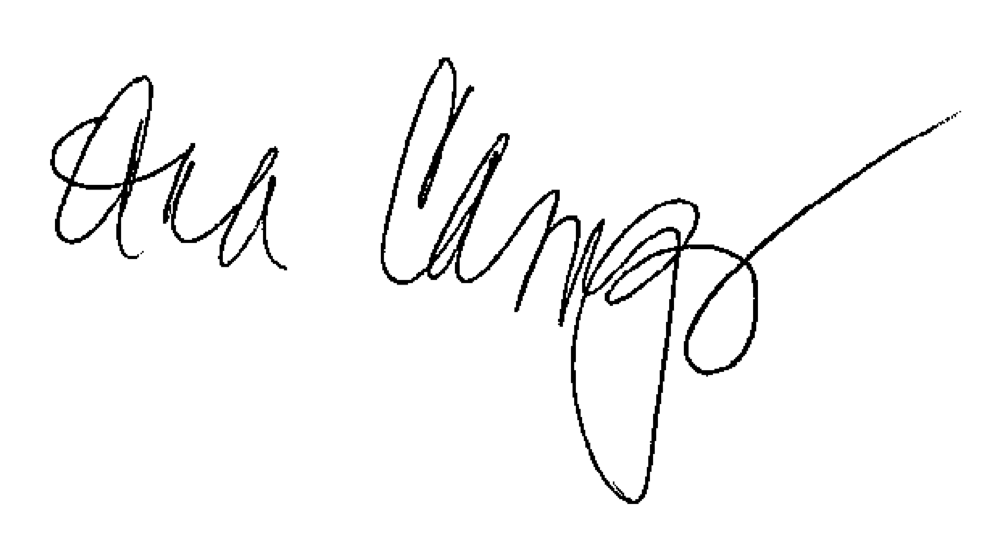
Signature of Authorized

Ana Campos
Printed Name

91-2162719
Employer I. D. / Social Security Number

May 18, 2021
Date

