LOS ANGELES LEADERSHIP ACADEMY HIGH SCHOOL
Board Report: September 27, 2022
Elsa Ochoa, Principal

- Enrollment: 197 as of 09/24/22
Grade | Enrollment
9th Grade | 40
10th Grade | 47
11th Grade | 49
12th Grade | 61

- Attendance: Year-to-date= 90.11%
Grade Levels | Attendance Percentage
9th Grade | 91.93%
10th Grade | 88.12%
11th Grade | 93.46%
12th Grade | 87.80%

School Actions
- Attendance phone calls made daily to families
- Independent Studies offered
- PBIS Attendance Incentives
  - Perfect attendance awards + incentives
  - Highest advisory attendance/month
  - Highest attendance grade level/month
  - Grade level perfect attendance days competition
- PESA Interns for truancy and absenteeism

- Academic Achievement
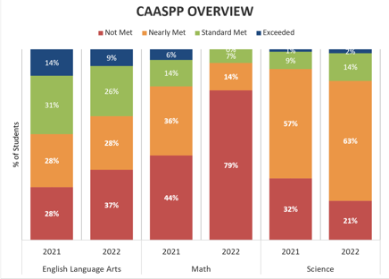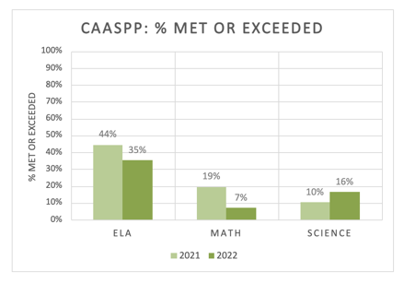
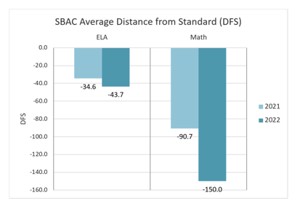

ELA
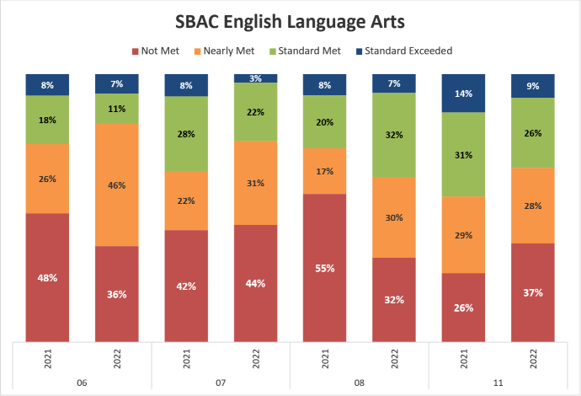

Mathematics
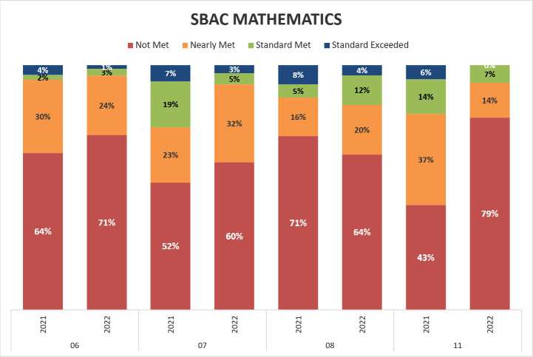

Additionally, in the 2021-2022 academic year 10 out of 41 students were reclassified.
24.38% Reclassification Rate

- Instruction & Supplemental Instructional Supports
- 12th Grade Parent/Guardian & Counselor meetings
- MyPath intervention program
- In-School Tutoring: Twice a week during study hall period; small groups no larger than 3 students
- Acellus credit recovery
- College tours with PESA
- ThinkTogether programming extended until fall break
- Cooking Class with John on Wednesdays
- Sports
  - Girls Volleyball
  - Basketball Practice
  - Baseball Club
  - Girls and Boys Flag Football Intramurals
- Elective Classes

- Professional Development & Teacher Support
- Weekly department meetings/Professional Learning Communities (August & ongoing)
- CPR Training (August)
- Social Justice and EDI Work (August)
- Initiated WestEd Mathematics Professional Development (August & ongoing)
- Monthly grade level meetings (August & ongoing)
- National Council Teachers of Mathematics Conference (Sept. 28-Oct. 1st)
- Visuals and Anchor Charts (September 28)
- Informal Classroom Observations (September & ongoing)
- Colleague Classroom Observations (September & ongoing)

- Discipline & Safety
- 22-23 Year-to-date: 0 suspensions
- Continue with PBIS implementation: ROAR (Respectful, Ownership, Active Learner, Responsible) expectations
- Counselor support: Mrs. Elibes Linos & Mr. Ruben Martinez
- 3 PESA Interns
- Emergency drills

- Parent/Guardian Communication
- Events with the Principal: monthly presentations with PESA
  - August 9: Pizza with the Principal Orientation and “Transitioning into 9th Grade”
  - September 10 Coffee with the Principal “Engaging Parents/Guardians”
- Lion News: monthly newsletters mailed to parents/guardians
- Counselor News: monthly newsletters mailed to parents/guardians
- ParentSquare reminders

- School Culture, Celebrations, & Events
  - Positive Office Referrals
- Student Council
  - Bulletin Boards
  - Announcements
- Homecoming Dance
- Green vs Gold
  - August 17 Clubs and Sports Rush
  - September 14 Hispanic Heritage Month
- 8th Grade Shadow Days
- Seniors
  - Senior Sunrise
  - UC Eligible Event
  - Posse Nominations
  - CSU and UC Workshops
  - September 23 UC Santa Barbara Field Trip
- Student of the Month: every teacher honors one student per month (Mandala word & following ROAR expectations)

