PARAMOUNT PAVERS & CONSTRUCTION
LIC. #977913
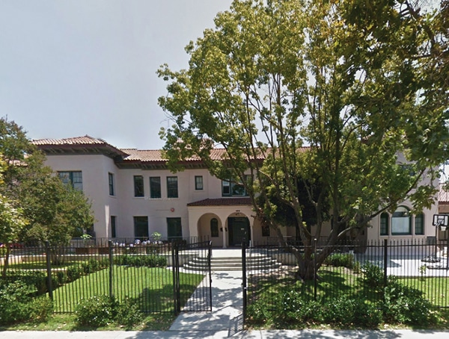
19528 VENTURA BLVD., SUITE 704
TARZANA, CA 91356
OFFICE (855) 705-4800
paramountpavers@gmail.com

PROPOSAL – 01/23/2023 (1 OF 3)

PROJECT NAME AND ADDRESS:
LOS ANGELES LEADERSHIP ACADEMY
2670 GRIFFIN AVENUE LOS ANGELES CA 90031

Preparation:
- Protect all work areas as needed prior to commencement of work
- Provide a portable potty and trash bins to the job site and or haul away debris periodically

Plumbing:
- Replace 2 (two) wall-mounted lavatory sinks, 2 (two) lavatory faucets, 2 (two) commercial toilets, 1 (one) commercial flush valves for toilets, 2 (two) soap dispensers, 2 (two) paper towel dispensers. - Replace 40-gallon electrical water heater.
- 1. Shut off the water, drain and remove old water heater.
- 2. Disconnect and remove old sinks, faucets, flex connectors, toilets, soap and paper towel dispensers.
- 3. Open walls where necessary to install support for the new lavatory sink. Relocate drain and water supply pipes for lavatory sinks.
- 4. Run new, copper type "L" pipes, fittings and coupling for hot water line.
- 5. Install 2 (two) new commercial lavatory sinks. Install 2 (two) new chrome p-traps underneath of lavatory sinks. Install 2 (two) new commercial toilets. Install 1 (one) new flush valve for the toilet, reinstall 1 (one) existing flush valve for the toilet. Install 2 (two) soap dispensers, install 2 (two) paper towel dispensers.
- 6. Install new 40-gallon electrical water heater, new stainless steel flex connectors and necessary shut off valves per code. Support water heater per code.
- 7. Open water, test all fixtures for proper operation.
- Clean up and haul away debris
- All work will be done up to code

Paint:
- Mask off all designated areas with plastic
- Prepare kitchen, two bathrooms, and entryway areas for new paint
- Apply one coat of primer to kitchen, two bathrooms, and entryway areas
- Apply one coat of paint to kitchen, two bathrooms, and entryway areas
- Clean up and haul away debris
- Note: All colors will be chosen and approved by owners

Owner’s signature ____________________________ Date _________________________
Page 1

PARAMOUNT PAVERS & CONSTRUCTION
LIC. #977913
19528 VENTURA BLVD., SUITE 704
TARZANA, CA 91356
OFFICE (855) 705-4800
paramountpavers@gmail.com

PROPOSAL – 01/23/2023 (2 OF 3)

PROJECT NAME AND ADDRESS:
LOS ANGELES LEADERSHIP ACADEMY
2670 GRIFFIN AVENUE LOS ANGELES CA 90031

Electrical:
- Provide and install two ceiling light/fan combo
- Relocate 200 Amp plug– New location to be approved by owner
- Install cover for junction electrical plug
- Clean up and haul away debris
- All electrical work will be done up to code

Flooring:
- Remove existing flooring in two bathrooms and entryway
- Clean up and haul away debris
- Provide and install new vinyl planks (color to be chosen by owner)
- Provide and install new vinyl base mounding
- Clean up and haul away debris
- All work to be done up to code

Cabinets:
- Prepare cabinet area for installation
- Provide and install new upper and lower cabinets in kitchen approx. 30 linear feet
- Provide and install open shelves approx. 8 linear feet
- Clean up and haul away debris
- All work will be done up to code

Paneling (Approx. 12 x 5):
- Remove panel in walk-in freezer ceiling
- Clean up and haul away debris
- Provide and install approx. 12 x 5 new paneling
- Clean up and haul away debris
- All work will be done up to code

**Materials in accordance to the specification stated above $19,055.00
**Labor in accordance to the specification stated above $23,980.00
Total project price including labor & materials: $43,035.00

Owner’s signature ____________________________ Date _________________________
Page 2

PARAMOUNT PAVERS & CONSTRUCTION
LIC. #977913
19528 VENTURA BLVD., SUITE 704
TARZANA, CA 91356
OFFICE (855) 705-4800
paramountpavers@gmail.com

PROPOSAL – 01/23/2023 (3 OF 3)

PROJECT NAME AND ADDRESS:
LOS ANGELES LEADERSHIP ACADEMY
2670 GRIFFIN AVENUE LOS ANGELES CA 90031

Schedule of payments:
Deposit upon agreement $1,000.00 Upon start of job and order of materials 40%
Upon 50% of job completion 40% Upon completion of entire job 20%
- Payments do not reflect the cost of each stage!

All materials are guaranteed to be as specified. All work to be completed in a workmanlike manner according to standard practices. Any alterations or deviation from the above specifications involving extra costs will be executed only upon written orders and will become an extra charge over and above the estimate.

ACCEPTANCE OF PROPOSAL (THREE PAGES)

The above prices, specifications and conditions are hereby accepted. You are authorized to do the work as specified. Payments will be made as outlined above.

Accepted:

Date: _____________________ Contractor’s signature: _________________________

Date: _____________________ Owner’s signature: ____________________________
- All work is guaranteed in accordance with the Contractors State License Board (CSLB)

